1. Create loan is no working

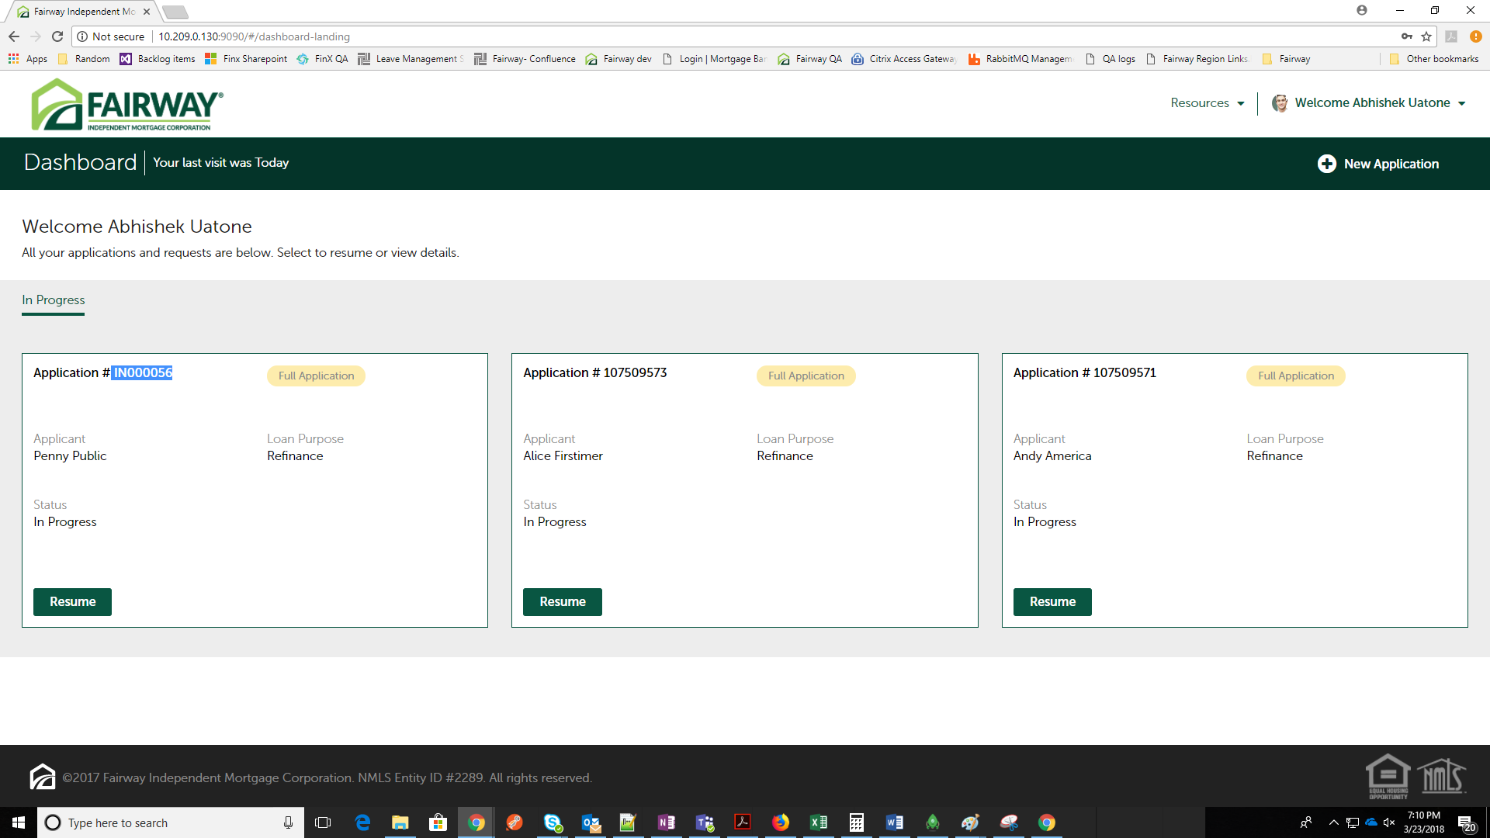

1. Borrower: In My current address question, do not check “This is mailing address”. Click on okay. There is no further navigation

{"timestamp":1521804840059,"status":500,"error":"Internal Server Error","exception":"java.lang.StringIndexOutOfBoundsException","message":"String index out of range: -1","path":"/addDynamicNode"}

1. Unable to edit Applicant’s data on Get started summary page

Error: {"timestamp":1521811012441,"status":500,"error":"Internal Server Error","exception":"java.lang.StringIndexOutOfBoundsException","message":"String index out of range: -1","path":"/processDynamicQuestionaire/FULLAPP_GET_STARTED"}

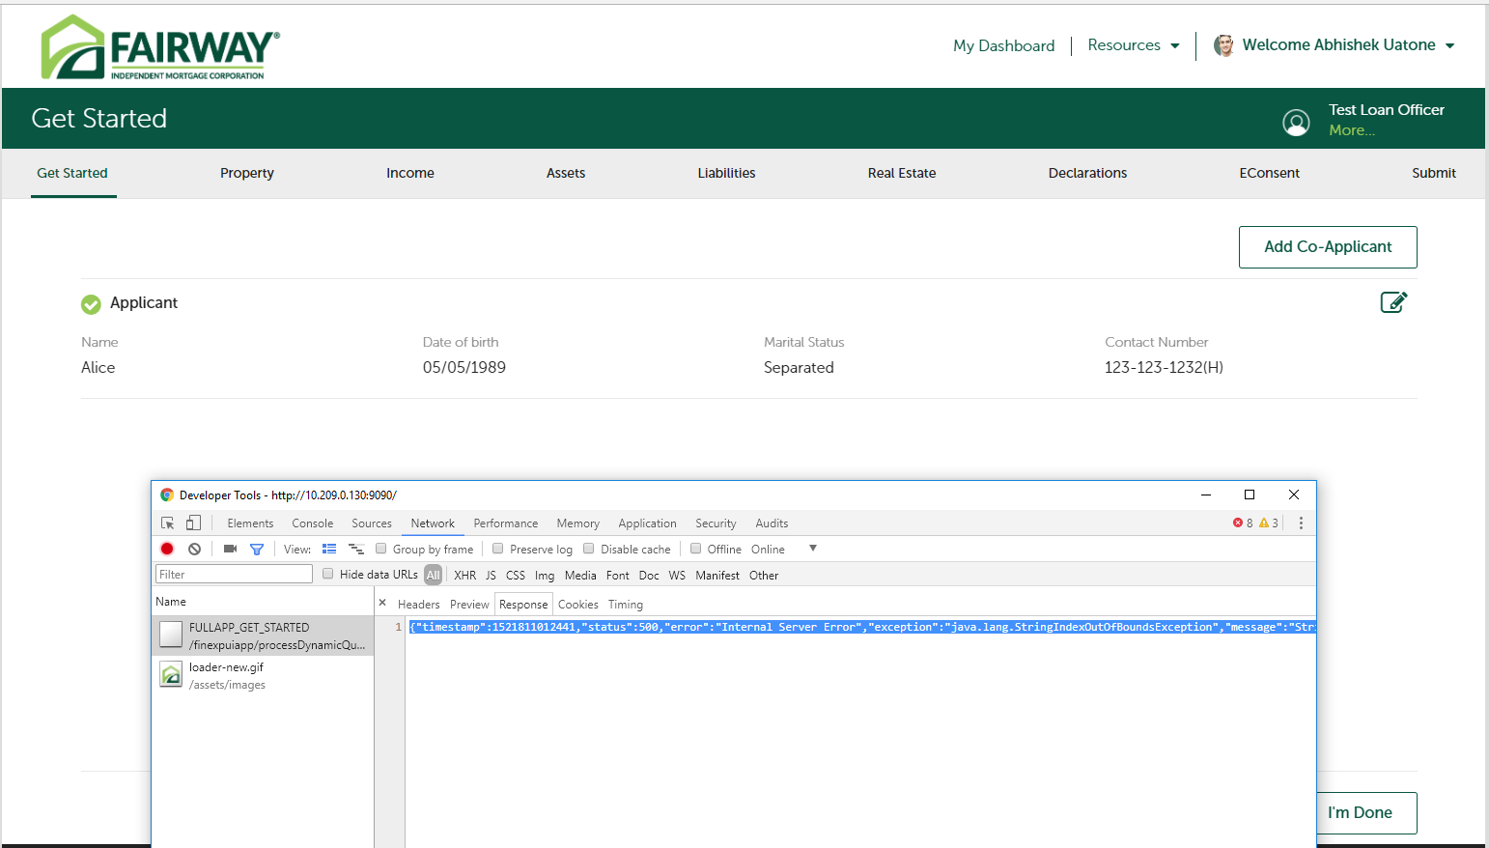

1. Co Applicant🡪 Check “I live with Applicant”, street address is not prefilled.

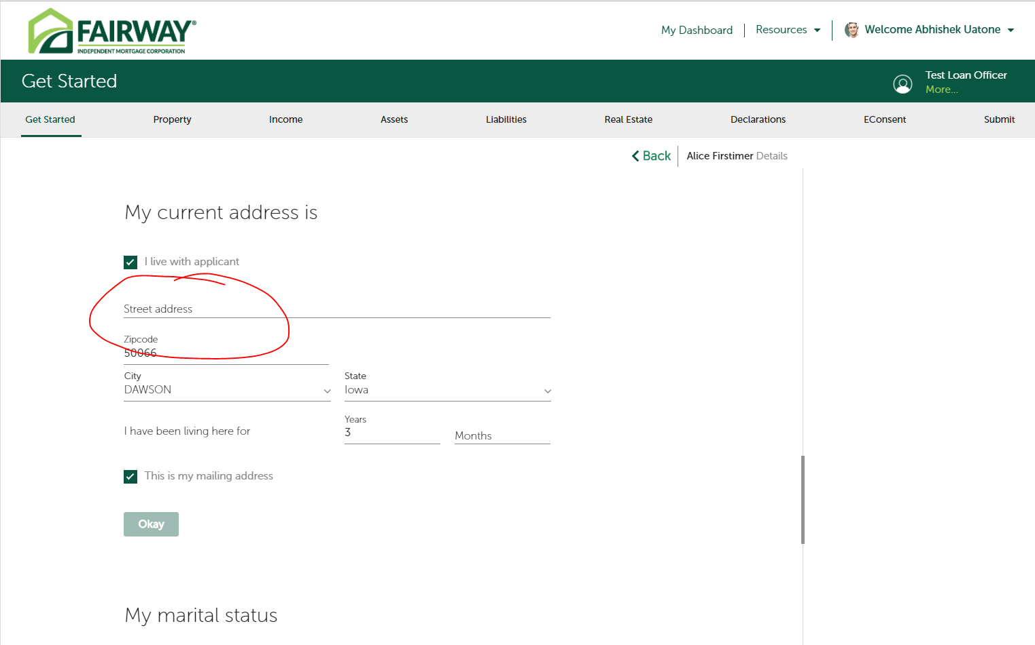

1. Complete providing Co applicant’s details. On Get started summary page, click on edit for Co applicant🡪 Street address provided is missing.

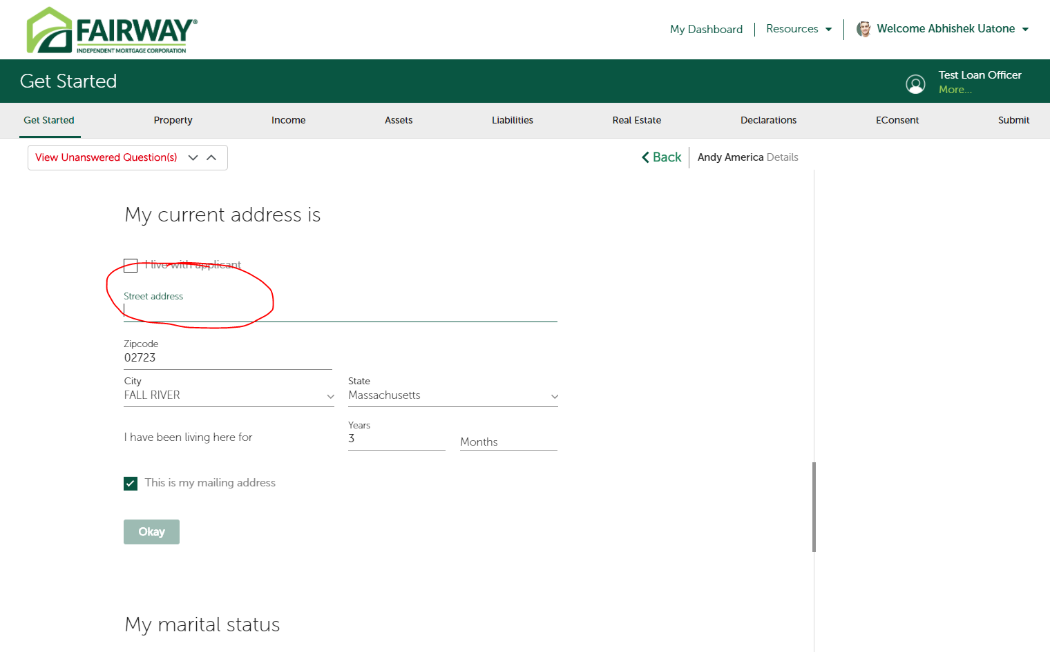

Co applicant:

"address" : [

{

"itemId" : "3e2874f9-9a49-4b65-9778-3f841e06c14f",

"residenceType" : "In a rented property",

"isAddressVerified" : true,

"cityName" : "DAWSON",

"stateName" : "Iowa",

"mailingAddress" : true,

"addressType" : "current",

"postalCode" : "50066",

"stateCode" : "IA",

"streetAddressLine1" : "",

"years" : 3,

"countyName" : "DALLAS",

"encompassId" : "Residence/0"

Applicant:

"personalDetails" : {

"haveDependents" : "No",

"firstName" : "Andy",

"lastName" : "America",

"address" : [

{

"itemId" : "3e2874f9-9a49-4b65-9778-3f841e06c14f",

"residenceType" : "In a rented property",

"isAddressVerified" : true,

"cityName" : "FALL RIVER",

"stateName" : "Massachusetts",

"mailingAddress" : true,

"addressType" : "current",

"postalCode" : "02723",

"stateCode" : "MA",

"streetAddressLine1" : "",

"years" : 3,

"countyName" : "BRISTOL"

}

Same is faced in Property section

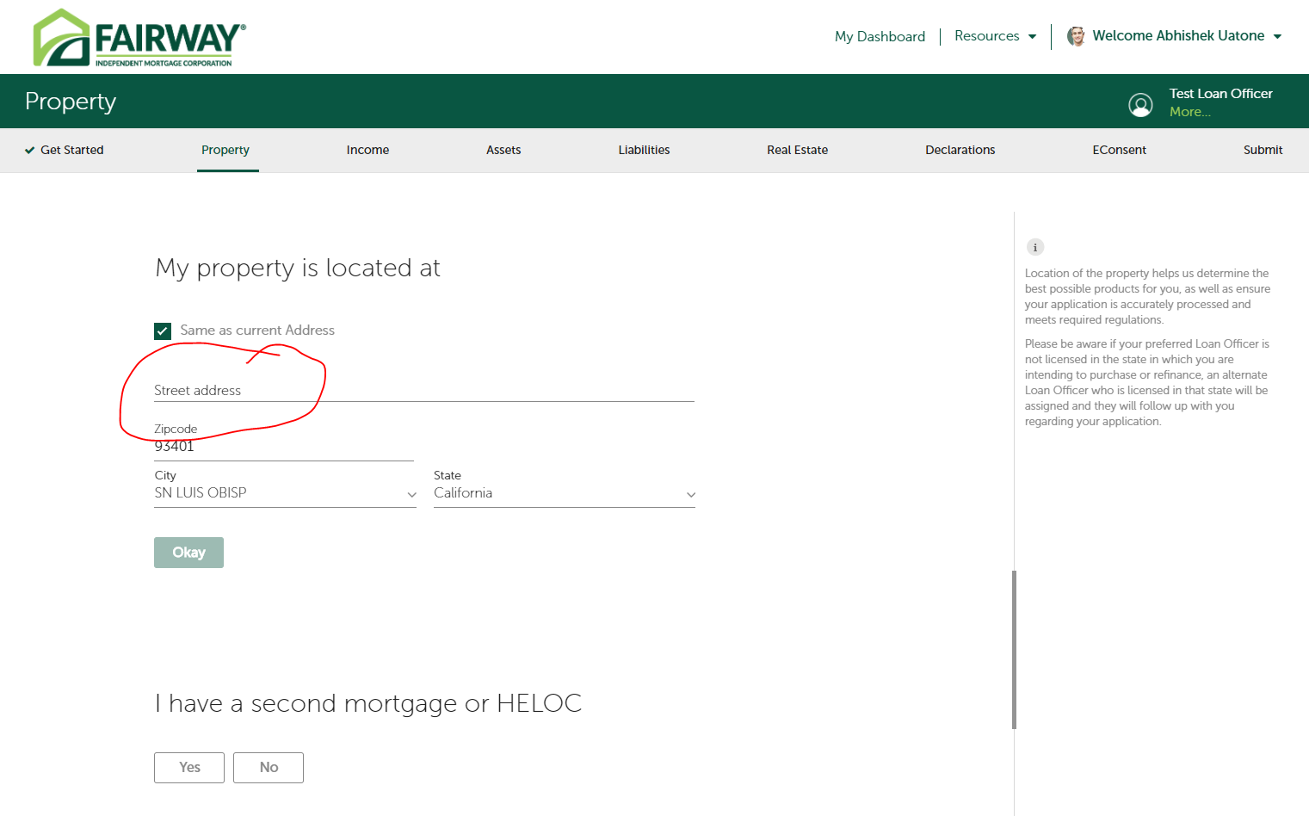

1. After successful income pull, below is the error shown to user.(Issue raised as part of last smoke test).

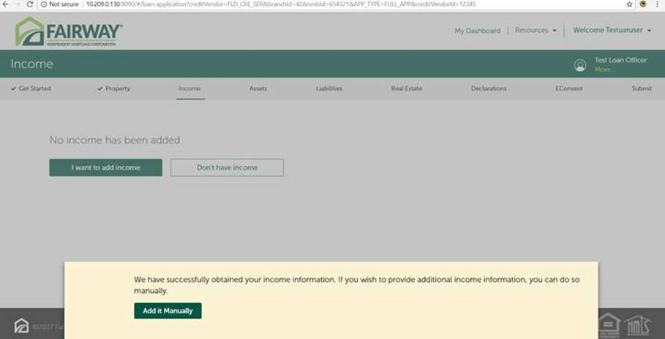

1. UI Issues  
   Assets

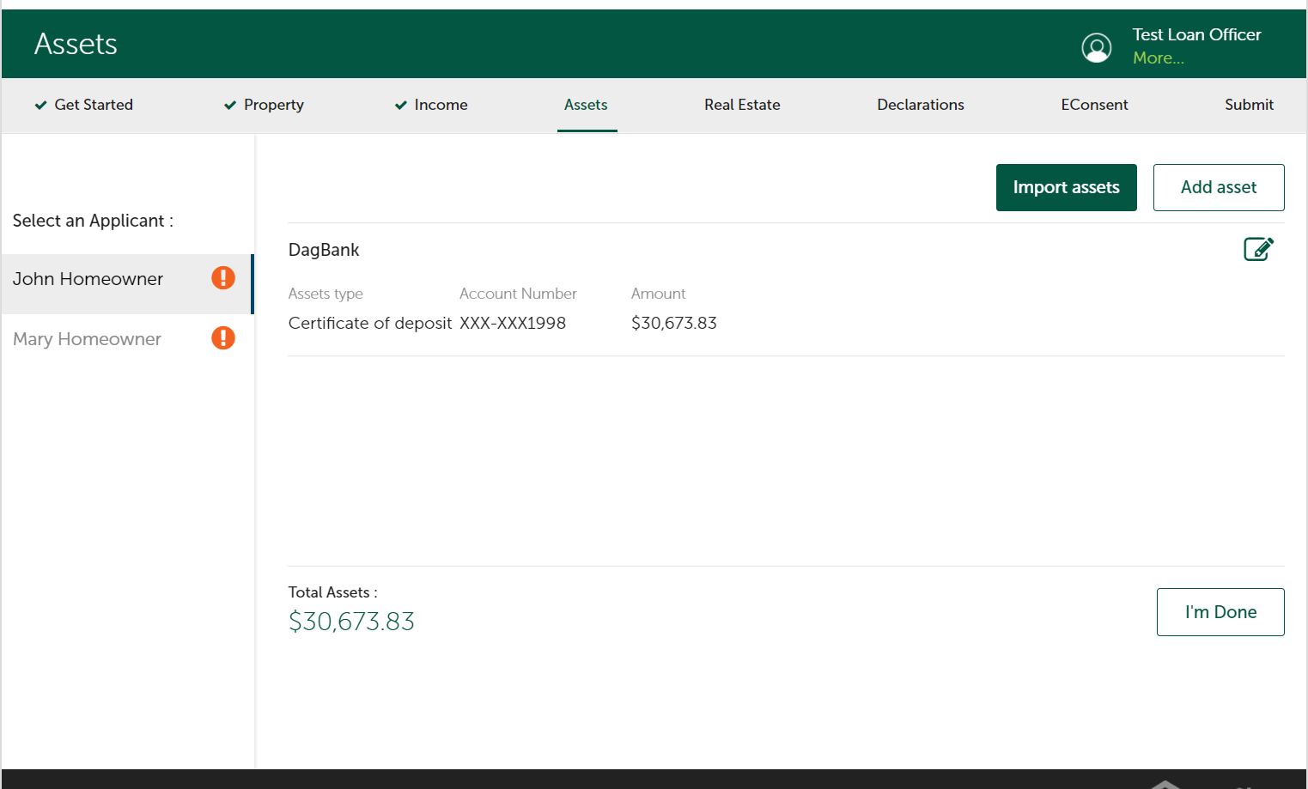

Real Estate

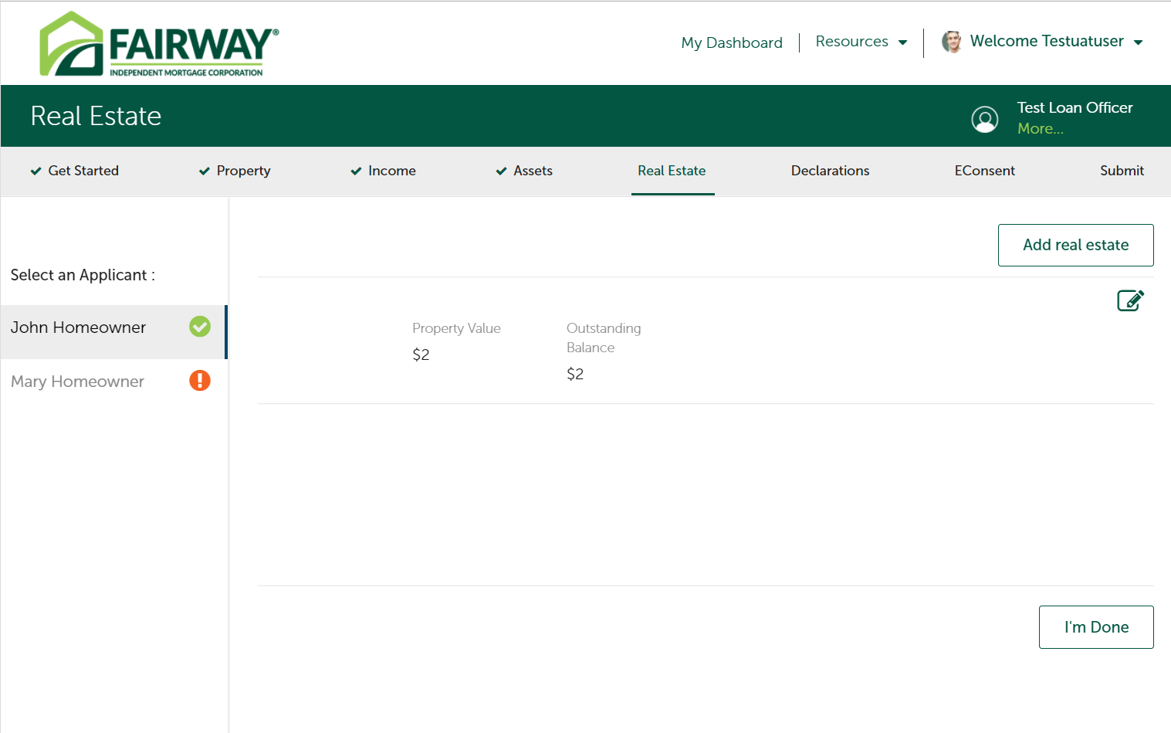

1. Unable to Submit the application- No error logs displayed- **Critical**